Project Design Phase Solution Architecture


Date Team ID
Project Name Maximum Marks
24 February 2026 LTVIP2026TMIDS73033
Educational Organisation using ServiceNow
4 Marks

Written Description of Solution Architecture The architecture of the “Educational Organisation Using ServiceNow” system is designed using

ServiceNow’s low-code/no-code environment. It includes custom tables, update sets, client scripts, process flows, and forms that integrate to automate the admission and academic progress tracking workflows.

Component 1.ServiceNowInstance

2.CustomTables 3.UpdateSets 4.ClientScripts

5.ProcessFlow
Description
Theprimaryplatformfordevelopmentand deployment of the educational management system
IncludesSalesforce,Admission,andStudent Progress tables to manage various datasets. Usedtopackageandtransfercustomizations from development to production instance. CustomJavaScriptforautomationlike
autofilling fields, calculating totals and percentages.
Workflowforvisualizingadmissionstatus(e.g., New→Joined→Closed). |

6.UIForms Custom-designedformsforAdmissionand Student Progress tables for data entry and review.
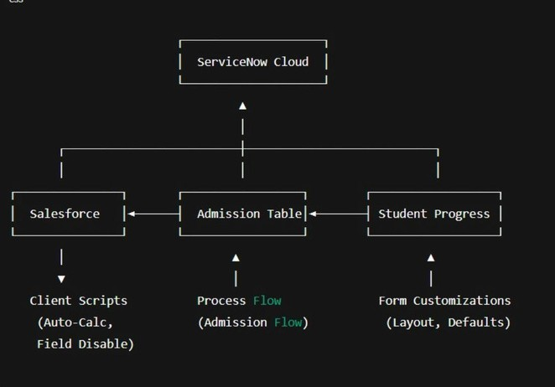
Diagram:

Architecture

